Group 34
Casper Athmer, 4329066
Bastijn Kostense, 4372972
Ludwig Kuester, 4505948

Assignment 3
3.1.1 Ant Preparation: Observe The Problem

3.1.1 Ant Preparation: Observe The Problem
1. Big open areas, loops and dead ends.

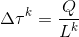
2. The equation for the dropping of pheromone is:

Where is the amount of pheromone dropped on a path by the k-th ant, Q is the estimated length, L is the length of the route that the k-th ant walked.

Pheromone is dropped as a signal to other ants, saying how promising a way is. Through the simple logic, that a shorter way is frequented more often in a given period of time, short ways are discovered though the pheromone. Thus pheromone enables the ants to effectively explore the environment.
The goal of the algorithm is to find the shortest way between points.

3. The equation for the evaporation of pheromone is:
Where ρ is the evaporation rate (between 1 and 0) and is the amount of pheromone dropped on a path.
In nature, ants will follow a once established, phreromone-parfumed way, even if later on a shorter way appears. Evaporation overcomes this flaw. Given a high evaporation rate, a long way will not be able to remain its pheromon level when competing with a shorter way. A low evapo-rate strengthens old known ways, a high one instead fosters exploration.

4. Pseudo code of ant-algorithm
Read maze and write it to a matrix;
Read start and end point to a vector;
Initialise parameters;
Create shortest route vector;
Translate start and end point to matrix coordinates;
Create four pheromone matrix, one for each walk-direction (e/n/w/s). Expl: Given a coordinate, the pheromone for each direction can be checked by asking the value of the (e/n/w/s) matrix of this specific coordinate.
For every iteration until max-iteration is reached or break though satisfiying the convergence criterion:
Create working-copies of the (e/n/w/s) pheromone matrix – added pheromone is stored here;
For every ant:
Create a temporary working-maze. Coordinates, the ant visited already, are set zero;
Set ant to start coordinates;
Create action array for ant;
While the ant has not reached the ending point yet:
Set current location in the temporary working-maze to zero;
Test for every possible direction (e/n/w/s),
if walking in this direction is possible (ant doesnt walk out of the maze)
else: set the respective pheromone for this direction
= (pheromone in this direction) ^ alpha * (the potential landing- coordinate's value in the temporary working-maze) ^ beta
Expl: So if the place I would go to is zero (not possible or already visited) the propability to go there becomes zero.
Amount all the pheromone of the four directions to a total;
If the total value is zero, set the maze's value of the current coordinate to zero and break; (Expl: As it means the ant got stuck. This already includes a solution to the problem of wide-spaces and dead-ends. Infact, those are incrementally filled with wall pieces, untill they are not longer a trap.)
Decide on the action to take with the roulette wheel method; then add it to the action vector;
update the route-length according to the new action vector;
pheromone-addition = (guess of the length of the route, Q) / route-length
Walk again the way the ant just took and add pheromone-addition to the corresponding matrix-coordinates;
If the way just walked is shorter then the previously know shortest, set as new shortest. Break, if new routelength satisfies the convergence criterion;
Break if the shortest route satisfies the convergence criterion;
Update the pheromone: Evaporate some and add the new one of the last iteration;
5: Improve the ant algorithm using your own insight. Describe how you improved the standard algorithm; which problems are you tackling and how? Limit yourself to 1 A4 text (excluding aiding figures).
The standard ant algorithm faces three main difficulties: loops, dead-ends and the handling of large empty spaces. Both loops and dead-ends involve the risk of encouraging non optimal behavior, if pheromone is dropped. Subsequent ants are incentivized to repeat walking in the same dead-end or running circles. In the worst case the whole algorithm remains fruitless due to endless loop-running or simply does not terminate naturally. Thus we experimented with different techniques tackling those challenges. It turned out that every method has its up and downsides.
Our initial idea was to allow each ant to use every cell only once. At the beginning of a trip, an ant would draw its own copy of the maze. There it would set every cell it is on to zero, just like wall elements. Hence once it finds itself surrounded by wall, it would abort its trip, drop no pheromone and set the cell it currently is on, the one it got stuck on, permantently in the main maze to zero. While the stuck ant dies, it closes this danger-spot for subsequent ants. This method shows to perform very stable. All chanllenges are mastered and paths are found even in the insane maze. Wide open spaces are filled with wall elements, which looping ants dropped once they stubled into a wall or their own path. Dead-ends are closed efficiently. It however turned out that the resulting paths are not always the shortest. A frequent pitfall is depicted in figure two: An ant meets its own tail, drops a wall element and dies. Thereby it unintentionally closes a key-passage in the maze. This passage is now blocked for all subsequent ants.
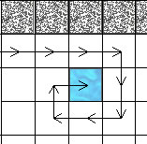Figure 1: An ant meets its own path and sets its last cell to 'wall'.
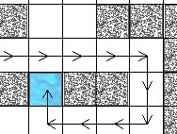Figure 2: An ant closes a key-passage.
We therfore modified the algorithm to find even shorter ways. The ant now marks all previously used cells with minus one. This brings about the advantage that an ant can identify whether it got stuck in its own path or a real dead-end. Each time an ant finds itself with no opportunity to walk to, it will check how many of the four possible options are blocked by its own path or real wall elements. In the case of 'three of them are walls' (the one I came from and a real dead end) and 'four of them are my own path' (I made a circle in open space) it still blocks the current position with a wall element. In case pf the other options, it will just die and drop neither a wall nor pheromone. This combines the advantage depicted in figure 1 and overcomes the pitfall of figure 2, as it leaves key-passages remaining open. The shortest path-length of the easy and medium maze were remarkably decreased. A value of 149 was reached for the medium maze – which appears to be near optimum. However, this implementation's downside is that many ants die without fasciliating subsequent ones a better performance. Unluckely it could not find results for any of the harder mazes.
At this point a clear problem is the 'death' of the ants. Non of them simply made it through a difficult maze without ever stepping on its own path or getting stuck in a dead-end. A clear problem is the handling of loops. While other groups equipped their ants with 'memories' such that ants would delete loops once biting their own tail and then walk on, we believe this undermines the very nature of swarm-intelligence. The beauty is that simple agents show complex behaviour as a group. Making the agents more complicated does not seems an elegant solution.

Thereupon a thorough research revealed stochastic means the most promising to solve the problems of looping without blocking shortest ways. First it was tried to allow each ant a crossing of the own path x times. This did not improve the performance. Second a more sophisticated pheromone drop was implemented. Ants would hereby remain walking, even if they crossed their own path or looped. As a reaction, the pheromone drop would simply decrease.
To further prevent looping, a fully random component was added to the process of making the 'walk-to' decision. If the [0,1] roulette-wheel random number is under a certain value v, the ant will simply walk in a totally random direction, regardeless of existing pheromone.
While the latter method in theory seems the most elegant one to us, it needs extensive value-research and further experience. Which value v satisfies 'no-looping' the best? The easy and medium maze could be solved, yet again, no adequate stability was achieved so to master the harder ones.

6: We did a lot of research regarding the parameters of the amount of pheromones dropped and the evaporation rate and we found values for the parameters that gave us optimal results. The values differ per map. On the easy maze, the optimal values were 40 for the amount of pheromones dropped and an evaporation rate of 0,1. On the medium maze, the values were 400 for the amount of pheromones dropped and again an evaporation rate of 0,1. 500 for the amount of pheromones dropped and an evaporation rate of 0,01 gave us optimal results on the hard maze. On the insane maze, 900 for the amount of pheromones dropped and an evaporation rate of 0,3 worked best for us. We also made figures that show the influence of the amount of pheromones dropped on different mazes, figures 1 to 4. In those four figures, we can see the relation between the amount of pheromones dropped and the final result, the length of the optimal path, on all the different mazes. The amount of pheromones dropped is plotted on the X-axis and the length of the final path is plotted on the Y-axis. We can see that the optimal results occur at higher amounts of pheromones dropped when the mazes get harder. This makes a lot of sense as it gets harder to randomly find a path when the mazes get harder, so more pheromones are good to have as they indicate a path to the end of the maze. We can also see that with certain very high and very low amounts of pheromones dropped at the insane maze, a path to the end of the maze could not be found. In figure 5, we can see the influence of the evaporation rate on the quality of the result. In this figure, we can see the relation between the evaporation rate and the final result on one maze. The evaporation rate is plotted on the X-axis andthe length of the final path is plotted on the Y-axis.. The evaporation rate has a little influence on the result, but doesn’t have nearly as big as an impact on the final result als the amount of pheromones dropped.

Converging fast means that the convergence criterion gets fulfilled in the least amaount of iterations, or when the convergence criterion is too low, that the parameters result in the best result.

We found our optimal parameters by changing one parameter at a time, and checking whether our result improved. If this was the case, we would keep the change, but if this was not the case, we would revert our change and try something else. When we found a value that was better than a slightly lower value and a slightly higher value, we would accept this as the optimal value. Of course, we don’t know for sure that this is the global optimum for the parameter, but otherwise we would have to exhaustively keep testing values which is not possible. We did this for both the amount of pheromones dropped and the evaporation rate, which gave us hopefully the global optimum but at least a local optimum. We did this for all the mazes and that is how we got our values for the parameters.

7. There is a relation between the influence of the values of the parameters and the quality of the final result. The bigger and complicater the mazes become, the higher the amount of pheromones dropped is needed for a better result. This makes sense because the more complicated a maze becomes, the harder it is to randomly find a path to the end of the maze. Once a path is found, it is better to stick to that path in a complex maze than in a very easy maze, because in an easy maze the chance is very big to randomly find another path to the end of the maze, where in a complex maze, this is not the case. This results in the fact that a higher amount of pheromones dropped is needed in a complex maze to get good results than in an easy maze.

8. A regular TSP problem is finding the shortest route that goes through all the nodes and returns to the original node, given an amount of nodes and the distance between all those nodes.

9. We do not know the distances between each node yet; we still have to uncover all the paths between the nodes.

10. Because we have to find the shortest path through all the nodes and back to the original node; the Ant algorithm can help us with this, and the Computational Intelligence techniques were very helpful for making this algorithm. Therefore, Computational Intelligence techniques are very helpful for solving a TSP.

11. What do the genes represent and how will you encode your chromosomes?
Genes are the single elements of the chromosome they compose. We use n genes per chromosome, where n denotes the number of products that need to be picked up. Every integer number from 1 till n can only appear once in each chromosome.

12. Which fitness function will you use?
The fitness functions measures the length of the tsp-path. The algorithms objective is to minimize this length. The shorter the way, the fitter a solution is. We use a quotient: Fitness = constant / path-length.
The quotient and its constant are introduced because of handyness.

13. How are parents selected from the population?
A combination of rank-based and proportional parent selection is used.
To create a new offspring, parents are first ranked by fitness. The ten best chromosomes are subsequently put in a pool together. For creating offspring, parents from this pool are then chosen via the roulette-wheel technique. This means a random number is drawn and parents get a proportion of the roulette-wheel according to their relative fitness.

14. The functions of your genetic operations (e.g. cross-over,mutation).
A crossover probability of 0.7 and a mutation probaility of 0.01 is applied. A random number decides according to the crossover whether this will be done. If so, genes from a random gene number on are swapped. It has to be ensured that all integer numbers up to n (the number of products) are contained and only once contained in each chromosome. Therefore after the crossover, those number which are still missing now are taken in chronological order from the respective other parent.
Mutation applies with its specific probability to chromosomes which have been made though crossover. (This in fact leads to a real crossover-probability of 0.69).
If for mutation is opted, two random different genes of one chromosome are swapped.
Mutation, crossover and cloning naturally add up to a total probability of one.

15. How do you prevent points being visited twice?
The security that every point is visited only once lays in the design of our chromosomes and the crossover-procedure. As every chromosome can contain every point only once, a point can not be visited twice.

16. How do you prevent local minima?
The mutation rate exists to prevent local minima. Altering the mutation rate upwards we aswell increase the number of chromosomes to ensure stability and few fluctuation.

17. What is elitism? Have you applied it?
Elitism describes that some number of best chromosomes get a sure ticket for the next generation. This ensures that the best solutions are not destroyed through crossover or mutation. We apply elitism though cloning each generation's first two chromosomes directly into the offspring group.

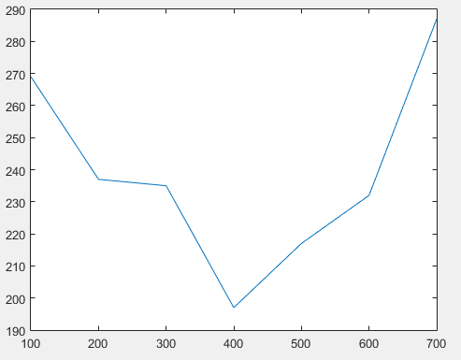
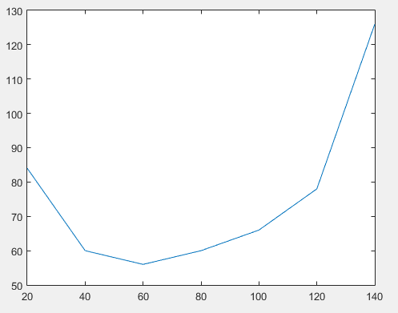
Figure 1, the results of the easy maze Figure 2, the results of the medium maze

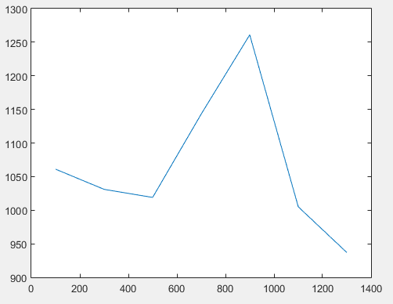
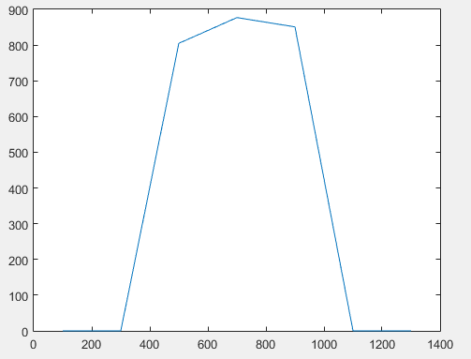
Figure 3, the results of the hard maze Figure 4, the results of the insane maze

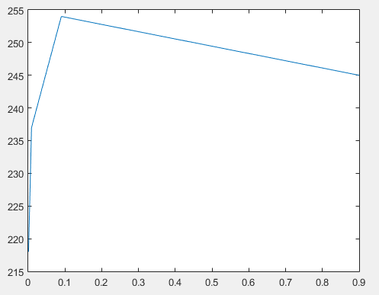

Figure 5, the results of the evaporation rate experiment

